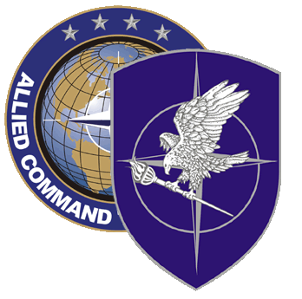
NATO SCHOOL: Global Leader in Multinational Military Education and Individual Training

N1-38 NATO Security Course

The aim of the NATO Security Course is to train NATO and national security personnel, who will be appointed to NATO security positions or to work with NATO security organizations on all aspects of Physical Security, Personnel security, Security of Information, INFOSEC, Industrial Security, Force Protection and familiarize them with the NATO Security Policy, especially with “Intelligence and Information Sharing with NNEs” and Security Awareness.

Course Length: 1 week

Offerings per year: 2

Class Size: 30 Max / 15 Min

Security Clearance: NATO SECRET

Rank Limitation: Any military member of the rank OF-2 to OF-5 in NATO HQ or NATO nations. The course is also open also to warrant officers, NCOs (OR-5 to OR-9) and civilians.

Prerequisites: Language proficiency: English IAW STANAG 6001 3333

Course Objectives:

At completion of the course, the student should be able to:

- Describe NATO security organization
- Explain the basic principles and minimum standards of Physical security, Personnel security, Security of Information, Industrial Security and INFOSEC as well as Security Awareness.
- Explain NATO security procedures.
- Explain NATO security inspections.
- Explain security education and training.
- List different threats to NATO and explain the need to have sound security practices.

